TROJAN HORSE EXPO
“ORIGINAL FACTORY FINISH ONLY”
Model Horse Show
Jackson, New Jersey
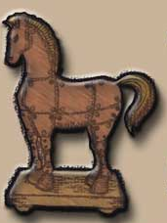
(Sunday, May 15, 2016)
NAN PENDING (As of xx-xx-16)
Location: Jackson Mills Fire Company No. 1
465 North County Line Road (aka Rte 526)
Jackson, NJ 08527
Time: Hall opens at 7am (Judges & Crew) 7:30 (Entrants)
Judging Starts 8:30 AM SHARP!

Entry Fee: $ 50.00 Entries Received prior to 2/29/16.
$ 55.00 Entries Received 3/1/16 – 04/14/16
$ 60.00 Entries Received 4/15/16 – 05/05/16
Proxy showers $2/horse limit of 10 total. (No Table space, you must arrange everything with proxy)
½ table per entrant (6ft.ROUND). Add $20 for the other ½ of table as supplies last.
Due to space/time limitations, there is a limit of roughly 30 showers and we must try to be done and out by 6pm.

Awards: New flat ribbons 1st -6th in all classes. (1st & 2nd placings in all classes qualify for NAN)
New Custom Rosettes to Div. Champs & Res.; 4 Div. Grands & Reserves..
Model must be present for the judge off.

Class Limits: 2 models/class/entrant

“Overstuff” – For those planning to place more than the allowed # of models in a particular class, we offer this solution: $1.00 per extra horse/per class above the Division’s legal limit to be placed on the table with the extra model(s) in question.

Division
Definitions: “OF CHINA” Division - This division is for all factory finished china/porcelain/other material mass production finish factory released models, finished by factory employees. Models may include H-R,Beswick, RD, RW, BHR, BFA, Alchemy (china), NL, Hartland and other china/porcelain models. (See Classlist for details in Collectable section).

“BREYER/OTHER MANUFACTURER” - This division is for all factory finished mass produced plastic models Breyer Models as well as other mass produced plastics such at Hartlands, Schleich, Blue Ribbon, etc..

“STONE HORSES” - This division is for all factory finished mass produced plastic models made by Stone horses.

Breed
Descriptions: A List is provided on the NAMHSA website. Remember, these are BASICS. We do NOT mind seeing an Appendix QH in a Sport Breed class, if the model looks like a sport horse and not a stock breed. Mustangs could go in any number of classes, depending on their look (stock, Spanish, etc.). Just remember – only ONE BREED CLASS PER MODEL. So if your Appendix QH doesn’t place in Other Pure Sport, we DON’T want to see it in QH/Solid Colored Stock Types! Please provide info cards on lesser known breeds/colors/manufacturers, etc.

Light Breeds
Ahkal-Teke, Arabian, Part-Arab (Anglo-Arabian, Ara-Appaloosa, Morab, NSH, Pintabian, - all Arabian crosses, [Arab pony crosses may be shown in a pony class] etc.), Morgan, Moroccan Barb, Shagya, Tersk, etc.

Gaited Breeds
American Saddlebred, Missouri Fox Trotter, Rocky Mountain Horse, (Spotted) Saddle Horse, Tennessee Walker, Walkaloosa, etc.

Spanish Breeds
Alter Real, American Indian Horse, Andalusian, Azteca, Banker Horse, British Appaloosa, Cerbat, Chickasaw, Criollo, Florida Cracker, Kiger, Lippizan, Lusitano, Mangalara, Mustang, Pasos (Columbian, Fino, Peruvian, etc.), Pura Raza Espanola, Costa Rican, Spanish Barb, Tiger Horse, etc.

Sport Breeds (those suitable for Carriage Driving, Dressage, Combined Driving, Combined Training, Hunting, Jumping or Racing)
Carriage Breeds - Cleveland Bay, Dutch Harness Horse, Friesian, Gelderland, Hackney Horse, Welsh Cob Section D, etc.
Warmblood/Sport Horse – any breed with “Warmblood” in its name. German would include Hanoverian, Holstein, Trakehner, etc. Others would include: American Warmblood, Appaloosa Sport Horse, Don, English Cob, Fredericksborg, French Trotter, Irish Draught, Knabstrup, Oldenburg, Orlov Trotter, Selle Francais, Standardbred, Thoroughbred/Warmblood crosses.

Stock Breeds
Paint and Other Pinto Colored Stock Types (white appears ABOVE the top of the forearm/stifle, and/or below the line from the eye to the muzzle): Mustang, Paint, QH, etc.
Appaloosa and Other Appaloosa Colored Stock Types: Appaloosa, Colorado Ranger, Mustang, etc.
QH and Other Solid Colored Stock Types: Appaloosa (w/o color), Australian Stock Horse, Colorado Ranger (w/o color), Mustang, Paint (Breeding Stock), QH, etc.
* App/Paint/QH/etc. Stock Horse Classes: In the real horse world, AQHA has dropped the restriction against white in the Quarter Horse. There are also other stock type breeds that can be patterned, such as stock type Mustangs (solid, appy and pinto) and Colorado Rangerbreds. These classes will be judged on breed standards and conformation, but we wanted to try out this split to account for coat colors to group “like” patterned stock horses together. Feel free to ask questions. Solid is defined here as any model that does not have white on the body (above the elbow/stifle) or on the face below a line connecting the eye to the muzzle, and includes brindle. Those with Pintaloosas – go in Mixed breed classes.

Draft Breeds
UK – Clydesdale, Gypsy Vanner, Shire, Suffolk Punch, etc.
Other – American Cream, Ardennes, Ardennais, Belgian, Breton, French Cob, Italian Heavy Draft, Jutland, Murakozi, Noriker, North American Spotted Draft, Pinzgauer, Percheron, Poitevin, Russian Draft, Soviet Heavy Draft, Sugarbush, Vladimir, etc.

Pony Breeds
UK – British Spotted, Connemara, Dales, Dartmoor, Eriskey, Exmoor, Fell, Hackney, Highland, New Forest, Shetland, Welsh A-C.
European – Galiceno, Gotland, Knapstrupper ponies, Merens, Skyros, Sorraia, etc.
Stock – Quarter Pony, Pony of the Americas, etc.
Other – Altai, American Show Shetland, American Walking Pony, Chincoteague/Assateague, Classic Shetland, Hokkaido, Newfoundland, Sable Island Ponies, Welara, etc.

Other Breeds
American Bashkir Curly, Dole, Falabella, Finnhorse, Fjord, Haflinger, Icelandic, Kathiawari, Knabstrup, Marwari, Miniature, Moyle, Pintaloosas, Other Pure/Mix…

Longears/Exotics.
Mules, Donkeys, Przewalski, Quagga(extinct or reconstructed), Zebra(all species), and crossbreds thereof, etc.

And if you don’t know the breed (it’s a mutt), it’s fine to say it is “GRADE” but at least try to give us a clue what’s in their make up.

Judging Criteria:

Halter – Breed Classes – Models will be judged on breed characteristics/standards, conformation, anatomy, biomechanics, build suitable to gender/age, realism and condition.
OF Collectability –(ALL SECTIONS) will be judged on age, condition, rarity, mold detail/shading, and other similar factors. Documentation/Info/Provenance Cards are REQUIRED!!! in this division not only for the Judge’s sake but to teach all of us about these seldom seen models. We all like to learn about new and interesting horsie things! ONE COLLECTABLE CLASS PER HORSE ( if they could fit in more than one , PICK THE BEST SUITED CLASS FOR YOUR MODEL!!)
The Show Committee/Show Coordinator reserves the right to combine classes with fewer than five (5) entrants. On the plus side, they may also split classes if they are huge!
Choosing Champions/Reserves – most will be chosen by callbacks. Points will be considered for Grand/Reserve. If your model places 1st in any class, you may be asked to transfer it & all its ribbons to the table area reserved for callbacks. This should save a little time…
CARDS & LEG TAGS:

Please read this section carefully.
NO CARD SYSTEM!!! Leg tags only. Judges will only be recording the 1st and 2nd place winner for each class so please remember to record your horses other placings for yourselves. "This should save time."
LEG TAG INFO:
You need to have a strung stationary tag affixed to your model’s leg. SIDE #1= Age, Color (optional) , Breed, Sex; SIDE #2= Models name & owner's 3 initials from entry form. SIDE #1 facing up during judging.

Special Lunchtime Classes
Fantasy Models: 3 classes for NAN qualification(yellow card) for Fantasy Models using the NAMHSA guidelines. OF China/ Resin, Breyer/Other, and Stone.
Fun Lunch Classes:
" Old School" Collector's class - 6-8 models centered around a common theme. Try to limit the area to 2.5ft x 2.5 ft
" Vintage Breyer animals" - show off your favorites that never seem to get to go to the show.
" Best Bloatie" - funny things happen to models when they have no airhole, sometimes inadvertantly...
" Best Funky Horse-Shaped Object (HSO)" for the artisticly conformationally challenged.. yes we can see they're horse shaped but I wouldn't want a real horse to look like THAT!
" Best Model Feline" any manufacturer
" Best Model Canine" any manufacturer
" Best Bovine" any manufacturer
" Best Farm Animal"any manufacturer... no cattle, they have their own class.
perhaps more....

$1 per entry in these FUN classes, Winner get half the class pot...More Info on these as the show grows closer.

MISCELLANEA/ SHOW ETIQUETTE
All belongings must be placed on or under your table. No spillage into walkways – this can be dangerous!
A Silent auction may be held during the day. Donations of tack, CMs, services are gladly welcomed. More information on what will be available will be sent at a later date. If you are interested in donating an item, please contact me at: dara1128@yahoo.com
COMPLAINTS about judging, smoking (FORBIDDEN in hall), etc., should be made to the show coordinator IMMEDIATELY. Please do not smoke within 20 feet of the doors (unless it’s raining), and please dispose of your cigarette debris in an appropriate manner (don’t just drop them on the ground).
LIABILITY – THE- Original Factory Finish Only MHS Show Committee, Judges and Jackson Mills Fire Company No.1 cannot be held responsible for any lost, broken or missing property, or injury to any participants or spectators.
DO NOT EVER PICK UP any exhibitor’s models without their permission. If you damage someone’s model, you’ll have to pay for it. The only exception to this is if someone has left a model on the judging table after their class; the show committee reserves the right to move it to the “PONY POUND”. They will be careful, but cannot be held responsible for any damages. Please instruct any of your guests on proper show hall etiquette. You are responsible for your family and guest(s) actions.
SMALL/YOUNG CHILDREN are NOT encouraged to attend this show. There are many expensive models displayed; parents are responsible for their children’s action in the event of any breakage/damage. Your fellow participants have enough stress to deal with without adding noisy or poorly behaved children. It’s a long day for adults – think of how a child might feel… Children under the age of 15 must be supervised by an adult at all times (i.e., they may not wander off on their own). Violation of this rule could result in being asked to leave the show hall and forfeiture of fees.
POOR SPORTSMANSHIP will not be tolerated. If anyone acts in such a manner, or does not obey directions of the Show Committee, will be asked to leave (also any family members) and will not be refunded any portion of their show fee.
NO ALCOHOL, BAD LANGUAGE, PETS, RADIOS/MUSIC, RUNNING or SMOKING in the show hall. And PLEASE, turn down your cell phones volume or change the ringer to vibrate.
PARKING – Remember to keep the front of the lot free of cars. ALL Unloading/Parking should take place in the rear of the Fire hall where there is plenty of parking.
LUNCH/FOOD – Will most likely be brought in (deli-style format or possibly pizza). We hope to break for lunch at 12:30-ish for probably 45-60 minutes or so). Lunch is included for showers/judges and show staff. Additional family members may partake of the luncheon provided at $5.00 per person. There’s also a Burger King, Bubbakoo Burritos, McDonald’s, Shoprite, Wawa, Pizza within 1/2 mile of the show hall but not within walking distance.
NO LOITERING - Please refrain from lingering around the show rings when judging is in progress, and refrain from talking while within earshot of the judges as they are judging. If you have questions concerning your placing, please ask the judge right after the pinning of that class so the information is still fresh in the judge’s mind. Judge’s decisions are final. All other questions should be asked prior to the start of judging preferably via email before the day of show.. (ie. “What class do you want Fjords in?”)
Please listen carefully for all announcements! There will be four (4) rings going simultaneously all day. You will need to be attentive.
For those who enter – the schedule may change a bit. Please review all confirmation correspondence and pre-show letters to be updated on any changes to or clarifications of rules/schedule/etc.
DIRECTIONS:
From NY & North NJ:

Via Garden State Parkway South to the Route 138 Exit 98 towards Rte 34 Belmar/I-195/Pt Pleasant/Trenton. Keep left at fork in ramp to Merge onto Rte 34N towards I-195W/Trenton/AllaireAirport. Merge onto I-195W towards Trenton. Take Exit 22 (Jackson Mills/Georgia) Stay to the left of the exit ramp (Jackson Mills). Go over the overpass & straight thru the first light. (You’ll see a sign for Shoprite & McD’s). Make a Left at the second light (County Line Road aka..Rte 526) Hall will be .9 miles on your right.

VIA NJ Turnpike South to Exit 7A towards Lakewood/Shore Points. Take Exit 22 (Jackson Mills/Georgia) Stay to the right of the exit ramp (Jackson Mills). Go straight thru the first light. (You’ll see a sign for Shoprite & McD’s). Make a Left at the second light (County Line Road aka.Rte 526) Hall will be .9 miles on your right.
From Trenton: Take I-195 East Shore Points to Exit 22 (Jackson Mills/Georgia) Stay to the right of the exit ramp (Jackson Mills). Go straight thru the first light. Make a Left at the second light (County Line Road aka..Rte 526) Hall will be .9 miles on your right.
From Philadelphia & SOUTH: NJ Turnpike North to Exit 7A (I-195 East) Shore Points. to Exit 22 (Jackson Mills/Georgia) Stay to the right of the exit ramp (Jackson Mills). Go straight thru the first light. Make a Left at the second light (County Line Road aka..Rte 526) Hall will be .9 miles on your right.
From Atlantic City & Shore Points: GS Pkwy North to Exit 98 Stay left to get onto I-195 W. Take I-195 W to Exit 22 (Jackson Mills/Georgia) Stay to the left of the exit ramp (Jackson Mills). Go straight thru the first light. Make a Left at the second light (County Line Road aka..Rte 526) Hall will be .9 miles on your right.
HOTELS/MOTELS
Radisson of Freehold (closest hotel) 50 Gibson Place, Freehold, NJ 07728…. (732) 780-3870 www.radisson.com

An internet search should provide more hotels but at a greater distance from the show hall. I do not have firsthand knowledge of these hotels attributes or detriments. Information gathered from internet search.
PET FOOD/ITEM DONATIONS: “THE- OFFO MHS” Committee asks that, if possible, entrants bring a small donation of unopened pet food (wet or dry), cat litter, old towels/blanket, and/or toys/treats for our local Ocean County Animal shelter in Jackson/ Jersey Shore Animal Foundation. In Memory of former shelter cat, Theo-kitty, who gave so much and asked for so little. He passes the torch of charity and love thru his new feline representatives, Adonis & Fozzie, and their canine minion, Dino.. Thanks everyone in advance for your generosity!
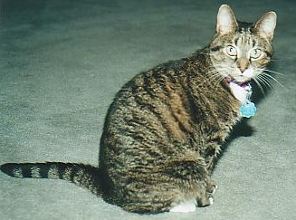
THEO
Sept 1995 – Dec 2010

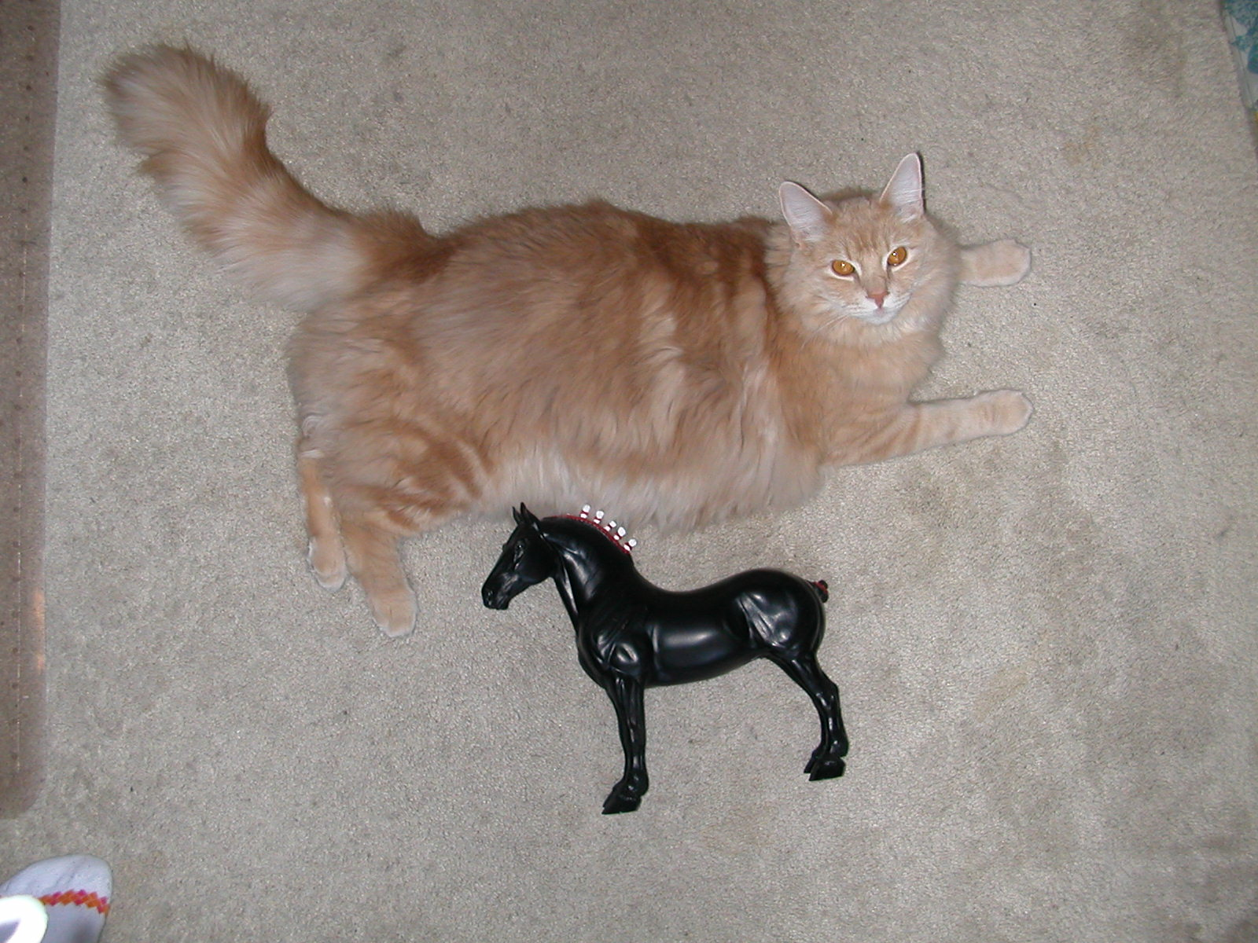

ADONIS
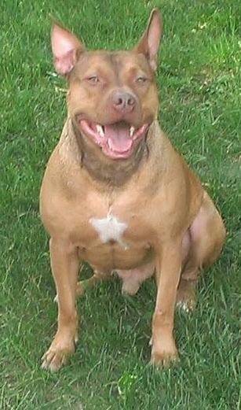
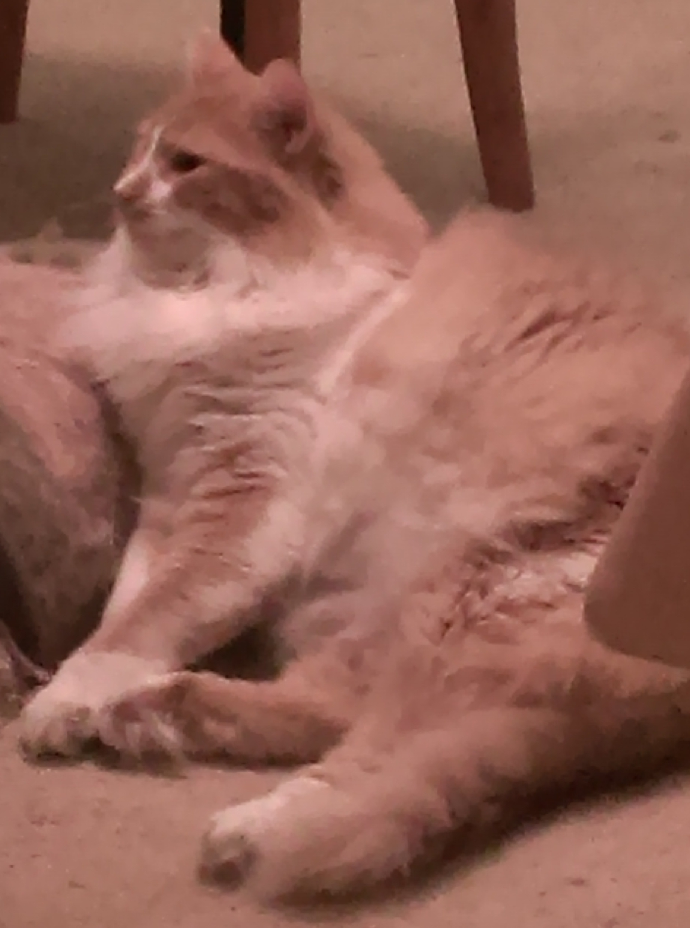
FOZZIE
DINO

TROJAN HORSE EXPO
“OFFO” ENTRY FORM
All information MUST be printed or typed legibly.

Name: ________________________________ Initials (3) to be used on tags:
(first, middle initial & last) 1st mid last

Street Address: ________________________________

City, State, Zip: ________________________________

Phone Number: (_____)_____-______ Cell #: ( ) - (optional, but most helpful)

E-mail Address: __________________________________ (for results and pre-show correspondence)

If you don’t have email, please send one large (#10) self addressed, stamped (1 stamp) envelope with this form so your entry can be acknowledged and initials assigned. Also include four extra first class stamps. Acknowledgment of your entry will take no more than three (3) weeks from the date of receipt.

Please circle or Hi-light divisions you’ll enter: Breyer Stone China Collectable How many people in your party? ______

FEES: Please fill in the appropriate amounts. Refer to Entry Fee Information

Show Fee: $________

TOTAL FEE: $________ Make checks payable to “Dara L. West”. (Memo: OFFO MHS)

Please note: Cut off date for receipt of entries is April 15, 2016. Payment can be made by via CHECK, POSTAL MONEY ORDER, PAYPAL or CASH(not recommended to sent through the mail). There is a $30 fee charged for any check that bounces. Paypal address is: dara1128@yahoo.com . Please send it as a add $5 to your total entry fee if paying by Paypal. Thank you.

I would like to be seated with/near: __________________________________________________________

Return this completed form with proper fees, SASE & extra stamps OR e-mail address to:

Dara L. West
1001 Poppy Place
Jackson, NJ 08527-2587

Please mark all correspondence with “THE-OFFO MHS.”

I (please print name) _________________________ have read and understand the rules of the Trojan Horse Expo - Original Factory Finish Only MHS (“THE-OFFO MHS”) and agree to abide by these rules, as well as the decisions of the judges and show coordinator/committee. I understand that if these rules are violated, I may be asked to leave the class/division/show with no return of fees paid. By signing this form and attending the “THE-OFFO MHS”, I hereby agree to these terms, and also release the”THE-OFFO MHS”, the Show Coordinator, Show Committee, Judges, sponsors and Jackson Mills Fire Company No. 1from liability for loss, damages or injury to any person or property which may occur during the show activities.

_____________________________________________________ _________________________________
Signature Date

If under 18, parent or guardian signature is required: _________________________________________________
Signature Date

